**CPSC 425 - Assignment 1**

Eloise Peng

13812169

Sept. 24, 2019

Part 1

Q1:

functions:

outputs

Q2:

functions:

output:

Q3

functions:

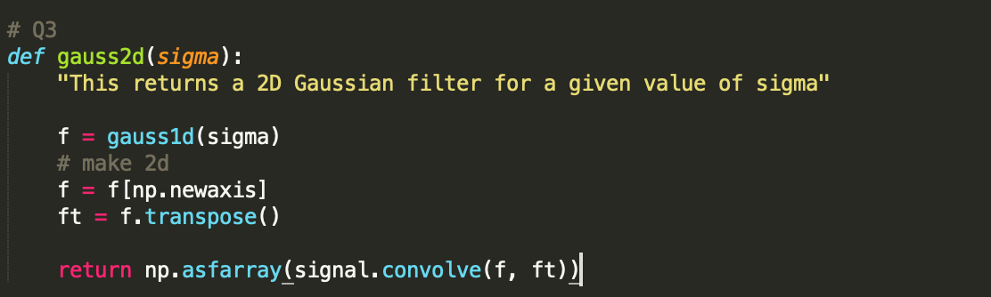

output:

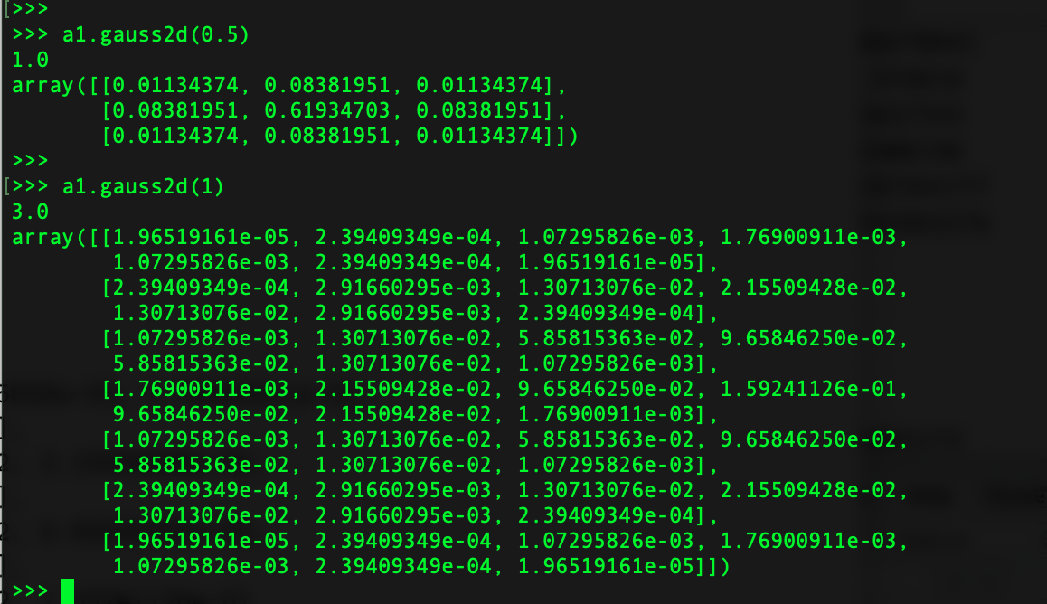

Q4:

a) ‘signal.convolve2d’ and ‘signal.correlate2d’ will produce a different result when the filter is non-symmetric.

b)

c)

Q5:

Since Gaussian kernels are separable, we can separate the 2D array into 2 vectors, and convolve each row and column accordingly. The new operation will reduce the runtime from

O(m^2 + n ^2) to O(m^2 + 2n).

Part 2

function:

Q1: Picked sigma = 5

>>> a1.lohipass_filter('dog.jpg', 5, False)

Q2: Picked sigma = 5

>>> a1.lohipass_filter(cat.jpg', 5, True)

demos:

#1

>>> a1.hybrid_filter('dog.jpg','cat.jpg',5,8)

#2

>>> a1.hybrid_filter('2b_marilyn.bmp','2a_einstein.bmp',9, 2)

#3

>>> a1.hybrid_filter('hp_lego1.jpeg', ‘hp_lego1.png',2,8)

#4

>>> a1.hybrid_filter('4a_bird.bmp','4b_plane.bmp',3, 20)

